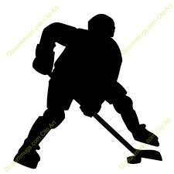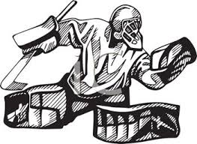
WINTER
STICKS & PUCKS AT HOBART ARENA

Friday, December 26 Tuesday, December 30
Monday, December 29 Wednesday, December 31

10:15am – 11:15am Ages 5 – 12
11:30am – 12:30pm Ages 13 - 18

- Sessions are $10 per skater.
- All equipment required per USA Hockey rules.
- USA Hockey certified coaches on ice at all times.
- Please enter venue @ Northeast corner of the building at Door #13.

